**Introduction to Views, Moving and Rotating a View Object**

https://www.youtube.com/watch?v=7V-JsPW2KHA&index=33&list=PLRtjMdoYXLf776y4K432eL_qPw4na_py3

#include "stdafx.h"

#include "SFML/Graphics.hpp"

#include <iostream>

#include <windows.h>

int main()

{

sf::RenderWindow window (sf::VideoMode(600, 600), "SFML works!");

sf::View view(sf::FloatRect(0, 0, 1500, 1500));

view.setRotation(0);

view.setCenter(300, 300);

window.setView(view);

sf::Sprite background;

sf::Texture texture;

texture.loadFromFile("background.jpg");

background.setTexture(texture);

while (window.isOpen()) {

sf::Event event;

while (window.pollEvent(event)) {

switch (event.type) {

case sf::Event::Closed:

window.close();

break;

}

}

if (sf::Keyboard::isKeyPressed(sf::Keyboard::W)) {

view.move(sf::Vector2f(0, -5));

}

if (sf::Keyboard::isKeyPressed(sf::Keyboard::A)) {

view.move(sf::Vector2f(-5, 0));

}

if (sf::Keyboard::isKeyPressed(sf::Keyboard::S)) {

view.move(sf::Vector2f(0, 5));

}

if (sf::Keyboard::isKeyPressed(sf::Keyboard::D)) {

view.move(sf::Vector2f(5, 0));

}

if (sf::Keyboard::isKeyPressed(sf::Keyboard::Q)) {

view.rotate(-1);

}

if (sf::Keyboard::isKeyPressed(sf::Keyboard::E)) {

view.rotate(1);

}

// Keep in mind that conventional x, y rules don't apply here

window.setView(view);

window.clear();

window.draw(background);

window.display();

}

}

**Result**

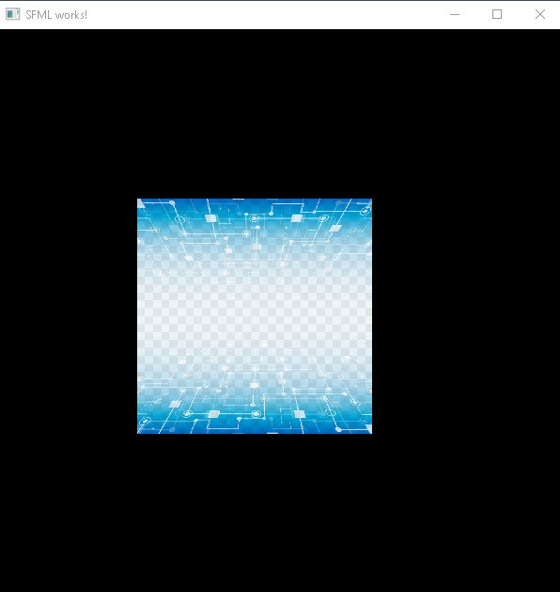

(Moves with Q, W, A, S, D, E)

**Important notes:**

* Keep in mind that conventional x, y rules don’t apply fully here: (5, -7) is considered (5,7) here